HTTP

1. HTTP is a hypertext transfer protocol. It's used to exchange data/content between the client and the server.  
     
   The three criteria for HTTP are:
   1. HTTP is connectionless; client disconnects, server can re-establish connection for the response
   2. HTTP can deliver any sort of data as long as both computers can read it
   3. HTTP is stateless; client and server know about each other ONLY during current request; in case of reconnection, it will be handled as the very first one.
2. 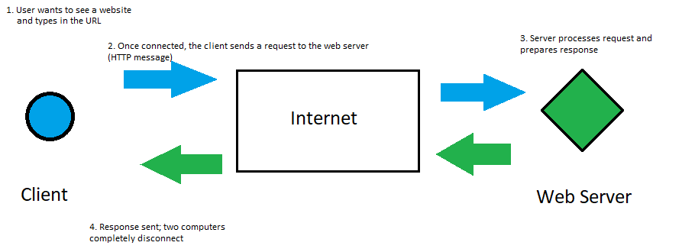
3. Status codes tells the client if the request succeeded or failed. There are other codes, but the usual ones are 200 (ok) and 404 (file not found).

MVC

1. 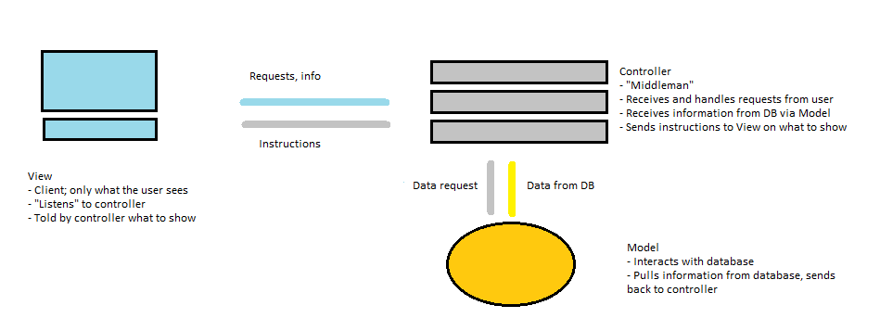
2. MVC model is used because it’s:
   1. Nicely structured and separated, making it easier to manage
   2. Built correctly, less need to repeat elements